

WAIVER AND RELEASE

I, for myself, my heirs, assigns, executors and administrators, do hereby waive and release any and all claims forever of any nature which I may have against Muscular Dystrophy Association, Inc. ("MDA®"), and all participating sponsors and supporters, for any injuries or damages, of any nature which I may suffer or any damages, destruction, or loss of my vehicle, including the loss from theft, or vandalism arising from or connected in any way with the Southern Knights Cruisers Car Show to be held on August 11, 2012 .

VEHICLE IDENTIFICATION

Print Name of Participant Make of Vehicle

Signature of Participant Model

Street Address Year

City State Zip Code

Date

Participants
- Classes: Early-1954, 1955-1972, 1973-1992, & 1993-Present. Dash plaques to the 1st 200 registered
- Open, judged show. Cars, trucks, motorcycles, emergency vehicles, and specialty vehicles are welcome
- All vehicles must be set up prior to 11 AM to be judged (no exceptions)
- Over 120 awards (Best of Show in each class, Top 25 in each class, Specialty Awards, Club Participation Longest Distance driven to the show, oldest participant, youngest participant, and more.
- Opening ceremony at 11:00 AM. More info available at: www.SouthernKnightsCruisers.com

Vendors - All vendors must be pre-registered. Contacts for space information and vendor application:
- Ricky Williams, Chairman, 804-526-8865, Email: uworime@comcast.net
==============================================================================
Registration $15.00 Pre-Registration Fee until July 30, 2012 ($25.00 starting July 31, 2012)
Make check payable to: MDA
Mail registration with check to: Southern Knights Cruisers, c/o Ricky Williams, 101 Comstock Dr., Colonial Heights, VA 23834 - NOTE: For confirmation of your registration, enclose a self-addressed, stamped envelope and/or enter your email address below.

Name:____________________________________________ Age:_________

Spouse/Other ____________________________

Address: ________________________________________________________________________________

Vehicle: Year __________ Make _____________________ Model _________________________________

Email address: ____________________________________________________________________________

Telephone #: (_______)______________ # miles driven to show:___________

Club (only 1 entry) ________________________________________________________________

Please sign the Liability Release Waiver Attached
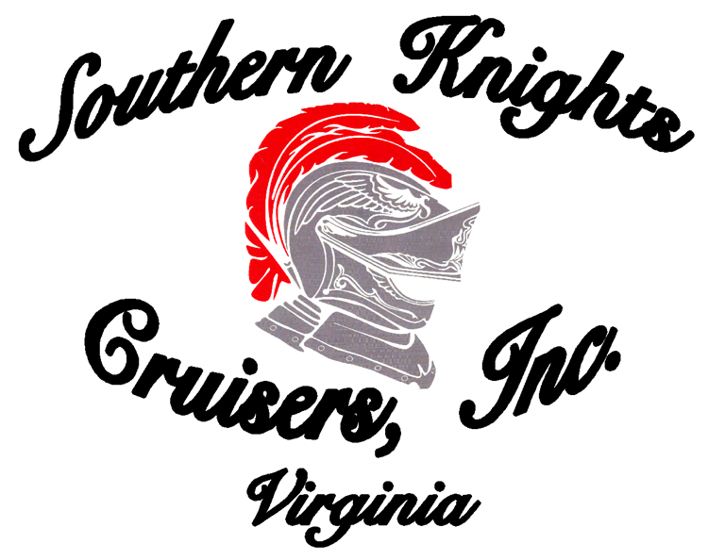
13th Annual MDA Car Show
“Helping Make A Muscle"

When: Saturday, August 11, 2012

Where: Richard Bland College
11301 Johnson Road
Petersburg, VA 23805

Directions: I-95 Exit 48B (Wagner Rd.) or I-85 Exit 65 (Squirrel Level Rd.) South of Petersburg - Just follow the signs.

